Dream-Terror Cell in Railway Box Cars
October 11th, 2023

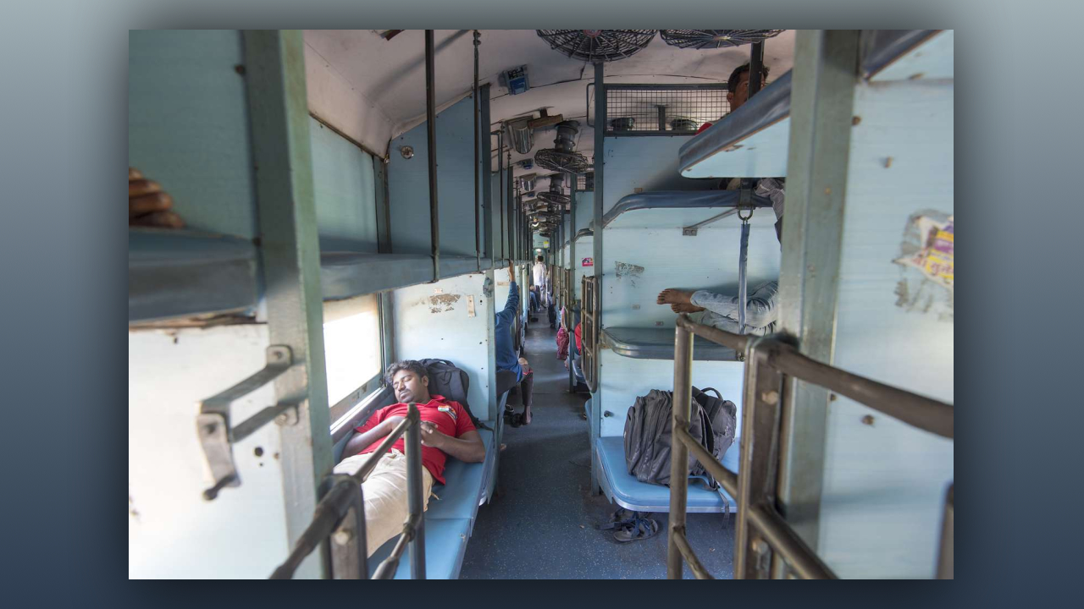
Dear family, this is a very urgent message to get out. Ezekiel had a dream of a railroad station, or tracks, that Donald owned a railroad company, Donald Trump, and that he was inspecting the boxcars to see if anyone was sloughing off on the job.

He was driving down the middle between two sets of trains, down the middle causeway, looking to see what the employees were doing, all of a sudden, he found someone who was not working. He stopped and fired him on the spot, but there was another man with him who was an al-qaeda operative, and Donald had uncovered a sleeper cell in the train yard.

Immediately rockets started firing and gun fights broke forth because there were men shooting from the backs of other boxcars. They were a cell and they had backup with all kinds of weapons, rockets and guns.

